CS-331 Software Engineering and Project Management

Hospital Management System
Ghulam Ishaq Khan Institute OF Engineering Sciences And Technology

Team Members Supervisor Details
Salman Shahzad Ali – 2023504 DS Dr Farah Saeed
Muqeem Ahmad Soomro – 2023561 DS Assistant Professor FCSE
Syed Murtaza Salman – 2023694 DS farah.saeed@giki.edu.pk
Ashir Siddiqui – 2023385 DS
Table OF Contents
- Page 1 – Title Page
- Page 2 – Abstract, Contribution OF each member, Project Proposal
- Page 3 – Project Definition
- Page 4 – Project Definition, System Analysis and Software Process Model
- Page 5 – Software Process Model

Abstract
This project, titled HealthMate, is a Hospital Management System designed to improve communication between patients and doctors through an online platform. The system allows patients to interact with doctors virtually, receive personalized guidance, and access medical consultation from anywhere. It integrates Artificial Intelligence through a chatbot that assists users in describing their symptoms and directs them to the appropriate doctor. The project follows the Agile Software Development Model, which ensures flexibility, teamwork, and continuous improvement throughout the development process. Overall, HealthMate aims to make healthcare more accessible, efficient, and affordable by reducing geographical barriers and enhancing patient experience through technology.

Team Formation
Contribution of Each Member
Salman Shahzad Ali – Will focus on The Software Development of the Web application. Will also learn and try to implement a chatbot.
Syed Murtaza Salman – Will work on databases and also learn the Artificial intelligence part and help others.
Muhammad Ashir Siddiqui – Will help in the integration part and finish his responsibility of learning and developing an Ai chatbot with specialized guidance.
Muqeem Ahmad Soomro – Will bring in his abilities of React and also develop the Ai chatbot he is assigned to do.

Project Proposal
Application Name – HealthMate
Application logo
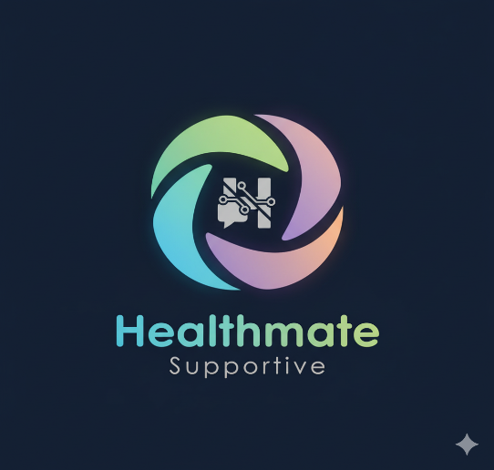

Project Definition
Scope
What the application will cover?
The application will cover the assistance of patients through the time he spends at a hospital. The application will give personalized attention to each and every patient. User will be first asked questions and then guided to the right doctor. The user will also be given a portal to discuss his symptoms and in detail get guidance. The user will also get the chance to interact with Specialized doctors as per his needs. The patient will also be given personalized resolution which will help him afterwards like what are the Do’s and Dont’s.
What the application will not cover?
The application will not cover anything regarding physical appointments between the patient and doctor all the meetings and diagnosis will be done online.

Objectives
Provide accessible guidance to patients from all over the world. Regardless of where they are present. The privacy of the patients to be hundred percent maintained. Provide cheap means of consultation for all users and also provide discounts to deserving cases. Provide the patients with the best consultation available.

Vision
The long-term purpose of this project is to remove the communication barrier between a patient and a doctor and also incorporate Artificial Intelligence in day-to-day life by bringing it into practice. The project will serve as a means of communication between patients and doctors and also give patients a hand on experience to interact with Artificial Intelligence.

Problem Statement
This project solves the problem of communication between users and doctors and removes the geographical barrier. Also provides the same level of medical health care to people sitting in remote places who don’t have access and transportation is very tiring and also expensive at the same time.

System Analysis
Existing System
In today’s times there exists some online mobile applications that do provide online video conferencing between doctors and patients but have zero involvement of Artificial Intelligence. Applications like Marham Connect exist where users can pay a decent amount and book a fifteen-minute call with the specialized doctor.

Disadvantages of existing system
There is zero involvement of Artificial intelligence and there is no chat bots present which can first listen to the customers medical needs and provide assistance. There is no Ai based guidance systems as to allocate the patients the right doctor they need to consult to.

Proposed System Functionality
The main features of the application are the incorporation of Artificial intelligence chatbots that will deal with the queries of the users and also learn patterns and make it more and more efficient. The incorporation of Ai will make the application more and more efficient as time will be saved and the customers will be allocated based on the observations of the Ai chatbot. The main advantage is time will be saved and the doctors will not have to waste time in redirecting customers.

Software Process Model
Agile Model
The Agile software development model is widely considered the best process model for development of Web applications. The best part of Agile is supports team collaboration and flexibility. It delivers working software quickly and adapts to change very easily to changing requirements. It reduces risk as you can test each and every phase.

Phases OF Agile Model
Requirement gathering and analysis
Requirements are gathered in form of user stories like meeting with the stakeholders which there aren’t any in this situation so we will gather information with the help of ChatGPT meaning ChatGPT is the stakeholder in this case.
Planning
All the requirements are prioritized into sprints the team decides which features to develop in each sprint.
Design
The UI/UX designs are made for sprint features. For example, a nice user interface of the chatbot will be made.
Development
The team will write code for the features planned in the sprint. The application is built incrementally.
Testing
Each sprint includes unit testing, integration testing, and user acceptance testing. Bugs are fixed quickly because feedback is immediate.
Review and Feedback
The team discussed what went well and what could be improved by having meeting with the instructor and also when the final product is presented in the class.

